

SUREKEY EXAMINATIONS BOARD

**PRIMARY LEAVING CONTROL SET EXAMINATION**

2022

SOCIAL STUDIES WITH RELIGIOUS EDUCATION

***Time Allowed: 2 hours 15 minutes***

**Index No. Personal No.**

**Candidate’s Name:** ………………………………………………………..………………………..

**Candidate’s Signature:** …………………………………………………………………………….

**School Name:** …………………………………………………………………………………………..

**District Name:** …………………………………………………………………………………………

**Read the following instructions carefully:**

**FOR EXAMINERS’**

**USE ONLY**

**Qn. No. MARKS EXR’S**

**NO.**

1 – 10

11 − 20

21 – 30

31 – 40

41 – 43

44 – 46

47 – 49

50 – 52

53 – 55

**TOTAL**

1. Do not forget to write your **school** or

**district name** on the paper.

1. This paper has two sections: **A** and **B**. Section **A** has **40** questions and section **B** has **15** questions. The paper

has **16** printed pages.

1. Answer **all** questions. **All** working for both sections **A** and **B** must be shown

in the spaces provided.

1. **All** answers **must** be written using a **blue** or **black** ball point pen or ink. Any work written in pencil will **not** be

marked.

1. Unnecessary **changes** in your work and handwriting that cannot be read

easily may lead to **loss of marks**.

1. Do not fill anything in the table indicated: **“For Examiners’ use only”** and boxes inside the question paper.

***©*** *2022 Surekey Examinations Board 0700758668* **Turn Over**

**SECTION A: 40 MARKS**

Questions **1** to **40** carry **one mark** each

1. By what process was Lake Kyoga formed?

………………………………………………………………….………………………………

1. Give any **one** reason why the government of Uganda carries out

a national census.

………………..…………………………………………………………………………………

1. Mention any **one** duty of the Bank of Uganda.

……………………………………………………………………………………………………

1. State **one** reason why the Ugandan government is constructing wider

roads in busy cities like Kampala.

……………………………………………………………………………………………………

1. Name the town where African Union was launched.

…………………………………………………….……………………………………………

1. How is equatorial climate described?

………………………………………………………………….………………………………

1. Why are Nigeria and Kenya regarded as Commonwealth countries?

…………………………………………………………….……….……………………………

1. Give any **one** cause of misunderstandings in your community today.

……………………………………………………………………………………………………

1. Where in South Africa was diamond discovered after the Great Trek?

……………………………………………………………………………………………………

**2**

1. Which group of people introduced long horned cattle in East Africa?

……………………………………………………………………………………………………………..

1. Apart from stopping slave trade, mention **one** other reason why the

British constructed the Kenya – Uganda railway.

…………………………………………………………………………………………………..

Below is a diagram of a national symbol for one of the countries in Africa. Use it to answer questions **12** to **14**.

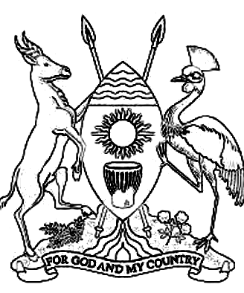

1. For which African country is the above national symbol?

……………………………………………………………………………………………………………

1. What do the spears and shield represent on the above national

symbol?

…………………………………………………………………………………………………………….

1. Mention any **one** natural physical feature colonialists used to create

boundaries for African countries.

……………………………………………………………………………………………………………

**3 Turn Over**

1. Give **one** reason why the British used indirect rule in Uganda.

…………………………………………………………………………….………………………………

1. Why is Lesotho regarded as an enclave?

…………………………………………………………………………………………………………….

…………………………………………………………………………………………………………….

1. Give any **one** way in which apartheid policy was practiced in

South Africa.

………………………………………………………………………………………………………….…

1. Name any **one** country in Africa that experiences Mediterranean

climate.

…………………………………………………………………………………………………………….

1. Which organ of the United Nations (UN) promotes world peace by

encouraging peace talks?

…………………………………………………………………………………………………………….

1. State any **one** factor that favours the growing of tobacco in the

West Nile region of Uganda.

…………………………………………………………………………………………………………….

1. Give any **one** way a father can promote peace among family members.

…………………………………………………………………………………………………………….

1. State any **one** way veterinary doctors can control the spread of

animal diseases from one area to another.

…………………………………………………………………………………………………………….

**4**

1. Give any **one** cause of a high population growth in an area.

…………………………………………………………………………………………………………….

1. How did Uganda People’s Congress (UPC) benefit from Kabaka Yekka

party in 1962?

…………………………………………………………………………………………………………….

…………………………………………………………………………………………………………….

1. Which body was created in Uganda to protect forests from destruction?

………………………………………………………………………………………………….…………

1. Apart from adding taste to food, mention any **one** other use of salt

at home.

…………………………………………………………………………………………………………….

Omol and Cosmos earn a monthly salary of 50,000 shillings and they

make their monthly expenditure as follows.

**COSMOS’S EXPENDITURE**

Medical - shs. 20,000

Transport - shs. 10,000

Fees - shs. 10,000

Savings - shs. 10,000

**OMOL’S EXPENDITURE**

Medical - shs. 20,000

Transport - shs. 20,000

Fees - shs. 20,000

1. Which type of budget does Cosmos use?

……..…………………………………………………………………………………………………

1. State any **one** problem Omol is likely to face because of using the type

of budget he is using.

………………………………………………….…………………………………………………..

1. How do the Benguela ocean currents influence the climate of Southern

Africa?

…………………………………………………………………………………………………….………

**5 Turn Over**

1. State any **one** reason why the government is carrying out rural

electrification.

……………………………………………………………………………………………….…

1. Give **one** reason why schools need to have hand washing facilities.

…………………………………………………………………………………………………………….

1. How can farmers in semi-arid areas be able to grow crops?

……………………………………………………………………………………………………….

1. State **one** factor that can attract more tourists to come to Uganda.

………………………………………………………………………………………………….…………

……………………………………………………………………………………………………………

1. Which element of wind is measured at a weather station using the

instrument below?

…………………………………………………………………………………………….………………

1. Give any **one** reason why European countries were fighting for

colonies in Africa.

……………………………………………………………………………………………………….…..

**6**

For each of the questions **36** to **40**, answer **Either** the Christian **OR** Islamic questions but **not** both. No **marks** will be awarded to a candidate who attempts both alternatives in **a particular number**.

1. **EITHER:**

Mention any **one** of the Ten Commandments God gave to Moses.

…………………………………………………………………………………………………

**OR:**

Mention any **one** pillar on which Islam is built.

…………………………………………………………………………………………………

1. **EITHER:**

Why will some people be sent to hell on the day of judgment?

…………………………………………………………………………………………………

**OR:**

Why will some people be sent to Jahanam on the day of judgment?

…………………………………………………………………………………………………

1. **EITHER:**

Mention any **one** organization that improves on the lives of Christians

in Uganda.

…………………………………………………………………………………………………

**OR:**

Mention any **one** organization that improves on the lives of Moslems

in Uganda.

…………………………………………………………………………………………………

**7 Turn Over**

1. **EITHER:**

What should Christians do to earn God’s forgiveness?

……………………………………………………………………………………………………………

**OR:**

What should Muslims do to earn Allah’s forgiveness?

……………………………………………………………………………………………………………

1. **EITHER:**

Give **one** reason why giving tithe in the church is important.

……………………………………………………………………………………………………………

**OR:**

Give **one** reason why it is important for Muslims to give Zakat.

……………………………………………………………………………………………………………

**SECTION B: 60 MARKS**

Questions **41** to **55** carry four marks each.

1. a) Give any **one** reason why the government carries out

decentralization.

……………………………………………………………………………..…………

b) What title is given the political head of the following units in

Uganda?

1. Local Council I ……………………………………………………….…
2. Municipality …………………………………………………………………

c) State any **one** role played by the Resident District Commissioner

…………………………………………………………………………..………..……

**8**

1. Study the sketch map of Africa below and use it to answer the questions that follow.

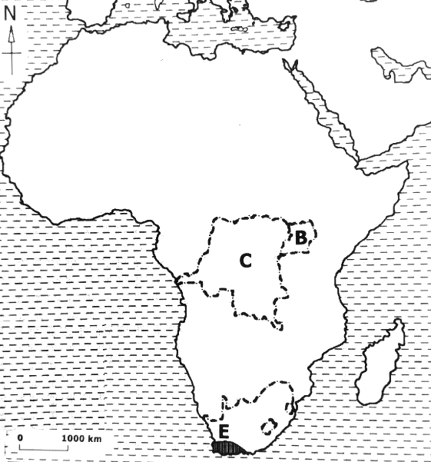

**M**

1. Name the regional economic bloc that promotes trade among

countries marked **B** and **C**.

……………………………………………………………………………………………

1. How is sea port marked **M** important in the economic

development of country **C**?

……………………………………………………………………………………………

1. Apart from country **B** and **C**, mention any **one** other country

that is a member of the economic bloc named in (a) above.

………………………………………………………………………………………….

1. Name the prevailing winds that bring rain to region marked **E**.

………………………………………………………………………………………….

**9 Turn Over**

1. a) Mention any **one** cause of the rising temperatures in the world

today.

…………………………………………………………………………………………

b) State any **two** ways countries of the world can control the

global temperatures from rising.

i) ……………………………………………………………………………………

ii) ……………………………………………………………………………………

c) Mention any **one** effect of the rising temperatures to farmers.

…………………………………………………………………………………………

1. Study the diagrams below and use them to answers the questions

that follow.

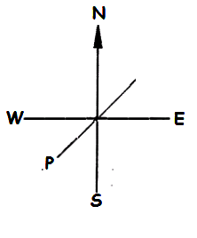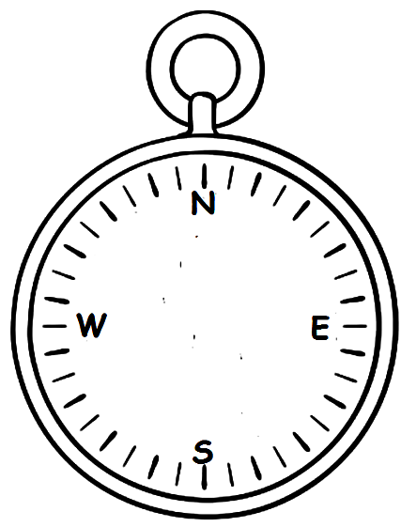Diagram **A** Diagram **B**

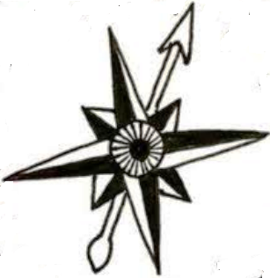

a) State **one** difference between diagram **A** and diagram **B**.

………………………………………………………………………………………..…

…………………………………………………………………………….…………....

b) Name the direction marked **P** on diagram **A**.

…………………..………………………….……………………………………………

c) Mention any **two** groups of people who use diagram marked B in

their daily work.

1. ………………………………………………….…………………………………
2. …………………………………………………………………………………….

**10**

1. a) Give any **two** reasons for the formation of LEGCO in 1921 in

Uganda.

1. …………………………………………………………………………………..
2. …………………………………………………………………………………..

b) Mention any **two** reasons why Ugandans were not happy with

the LEGCO that was formed in 1921 during colonial times.

1. …………………………………………………………………………………….
2. …………………………………………………………………………………….
3. a) Why are cultural weddings regarded as social activities?

………………………………………………………………………….………………..

b) Apart from cultural weddings, mention any **two** other examples of

social activities in your community.

1. …………………………………………………………………………………….
2. ………………………………………………………………………………………

c) State **one** reason why somecultural social activities are

dangerous to people.

………………………………………………………………………………………….

1. a) How did the Kikuyu of Kenya react to the white settlers’

attempts of occupying the Kenyan highlands by force?

………………………………………………………………………….…………..……

b) Mention any **two** famous Kenyans that mobilized fellow Kenyans

to react against the white settlers.

1. ……………………………………………………………………………….….…
2. ……………………………………………………………………………………..

c) Give **one** reason why the Kenyans reaction against the

white settlers took long to end.

………………………………………………………………………………………….

**11 Turn Over**

1. Study the sketch map of East Africa below and answer the questions that follow.

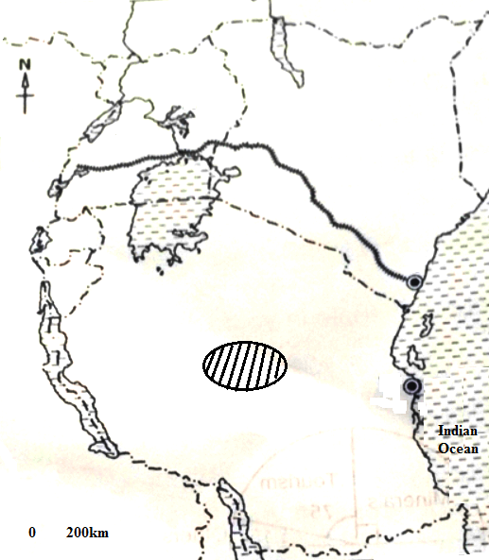

**W**

**S**

**B**

**Q**

1. What role did George White House play in the construction of

railway line marked **S**?

………………………………………………………………..…………………………

1. Name the type of coffee that grows well on the slopes of

Mountain marked **W**.

……………………………………………………………………………………..……

1. Mention any **one** problem cattle keepers in area marked **Q** face.

……………………………………………………………………..……………………

1. How can fishing be improved on lake marked **B**?

……………………………………………………………………………………………

**12**

1. a) **List A** below shows some of the tribal groups that settled in

East Africa with places of their origin in **List B**.

**LIST A LIST B**

1. Bantu Bahel gazel
2. River-lake Nilotes Ethiopian highlands
3. Plain Nilotes Cameroon highlands

Choose the correct place of origin in list B and write it to the tribal

group that it matches with in the spaces below.

i) Bantu …………………………………………………………..……

ii) River-lake Nilotes ………….……………………………………………….……

iii) Plain Nilotes …………………………………………………………………

b) How did the migration and settlement of the above tribal groups

affect the indigenous people they found in East Africa?

…………………………………………………………………………………………….

1. a) Give any **two** reasons why Arabs came to East Africa.
2. …………………………………………………………………………………..
3. …………………………………………………………………………………..

b) What form of money did the Arabs introduce in East Africa?

………………………………………………………………………….……………….

c) How did the introduction of legitimate trade affect Arab traders

in East Africa?

………………………………………………………………………….……………….

For each of the questions **51** to **55**, answer **EITHER** the Christian **OR** Islamic questions but **not** both. **No mark** will be awarded to a candidate who attempts both alternatives in **a particular number**.

1. **EITHER:**

a) Mention any **two** services you as a child can offer to the Church.

i) ……………………………………………………………………………………

ii) ……………………………………………………………………………………

**13 Turn Over**

b) Give any **two** ways Christians prepare for church service.

1. ………………...………………………………………………………………….
2. …………………………………………………………………………………….

**OR:**

a) Mention any **two** services you as a child can offer to your Mosque.

i) ……………………………………………………………………………………

ii) ……………………………………………………………………………………

b) Give any **two** ways Muslims prepare for Jumah service.

1. ………………...………………………………………………………………….
2. …………………………………………………………………………………….
3. **EITHER:**
4. Mention **one** way Christian children show obedience to;

i) God …………………………………………………………………………...

ii) parents ……………………………..………………………………………..

1. State any **one** way children benefit from being obedient to God.

……………………………………..……………………………………………………..

c) Write down **one** result of disobeying parents.

…………………….………………………………………………………………………

**OR:**

1. Mention **one** way Muslim children show obedience to;

i) Allah …………………………………………………………………………..

ii) parents ……………………………..………………………………………….

1. State any **one** way children benefit from being obedient to Allah.

……………………………………..……………………………………………………..

c) Write down **one** result of disobeying parents.

……………………………….……………………………………………………………

**14**

1. **EITHER:**

“Then they got Joseph’s robe, slaughtered a goat and dipped it in the blood. They took it to their father ……..He recognized it and said, “It is my son’s robe! Some ferocious animal has devoured him. Joseph has surely been torn to pieces.’’ **(Genesis: 37:32-33)**

1. Who was the father of Joseph they took the robe to?

…………………………………………………………..………………………………

1. What had Joseph’s brothers done to him before dipping his robe

in a goat’s blood?

……………………………………………………………………………………………

1. Why did Joseph’s brothers plot against him?

……………………………………………………………………………………………

1. Write down **one** lesson you learn from the story of Joseph.

……………………………………………………………………………………………

**OR:**

“And they brought his shirt, stained with false blood. He responded, ”No! your souls must have tempted you to do something evil to my son. So, I can only endure with beautiful patience. It is Allah’s help that I seek to bear your claims.’’ **(Quran: 12:18)**

1. Whose shirt was brought stained in false blood?

…………………………………………………………..………………………………

1. Who was the father of the person named in (a) above to whom

the shirt was brought?

……………………………………………………………………………………………

1. What had the people who brought the shirt done to their brother?

……………………………………………………………………………………………

1. Write down **one** lesson you learn from the above verse.

……………………………………………………………………………………………

**15 Turn Over**

1. **EITHER:**
2. Mention any **one** talent God gives to His people.

………………………………………………………………………………………....

1. State any **two** ways talents can be discovered.
2. ………………………………………………………………………………….
3. ………………………………………………………………………………….
4. How do Christians benefit from their talents?

………………………………………………………………………………………....

**OR:**

1. Mention any **one** talent Allah gives to His people.

………………………………………………………………………………………....

1. State any **two** ways talents can be discovered.
2. ………………………………………………………………………………….
3. ………………………………………………………………………………….
4. How do Muslims benefit from their talents?

………………………………………………………………………………………....

1. **FOR BOTH CANDIDATES TO ATTEMPT:**
2. Give any **two** similarities in belief between Christians and

Moslems.

1. ……………………………………………………………………………………
2. ……………………………………………………………………………………
3. Name the Holy Book used in Christianity / Islam.

…………………………………………………………………………………………

1. Give **one** reason why the book named in (b) is called a Holy

Book in Christianity / Islam.

……………….…………………………………………………………………………

**16 END**